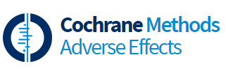
Sign-up to this Methods Group and others here
https://methods.cochrane.org/adverseeffects/
2020 Key Outputs
Convenors: Su Golder, Daniela Junqueira, Joey Kwong, Yoon Loke, Sunita Vohra

Highlight:
Improving reporting of adverse events through our partners in CONSORT

Research and development
- Understanding Public Attitudes Toward Researchers Using Social Media for Detecting and Monitoring Adverse Events Data
- Assessment of Beliefs and Attitudes About Statins Posted on Twitter: A Qualitative Study
- Comparison of drug safety data obtained from the monitoring system, literature, and social media: An empirical proof from a Chinese patent medicine

Best practice and guidance
- Reporting of harms in clinical trials: overview of the adherence to CONSORT Harms

Research Integrity
- Actively involved in projects investigating research integrity, in particular, detecting issues of validity, reliability, analysis, robustness in publications / data in primary studies; and
- Biased selection of data for meta-analysis in systematic reviews

