Meeting title: RoB 2 Pilot Web Clinic
Location: GoTo Meeting
Date and time: 30 July 2020, 16:00-17:00 (BST)
Recorded: Yes (all past recordings are available here)

Chair: Kerry Dwan (Methods Support Unit Lead and Statistical Editor)
Other organisers: Tess Moore (Systematic Review Methodology Editor), Ella Flemyng (Methods Implementation Coordinator), Bias Methods Group
Attendees: N=23 attendees
Notes: Tess Moore (Systematic Review Methodology Editor)

Notes
1. Update from last Web Clinic

- Updates from last Web Clinic:
  - Update on numbers of Reviews in the Pilot.
62 reviews in the pilot with 17 that have expressed an interest. Nine have switched RoB 2 on in RevMan Web
Three reviews have been submitted for peer review.
Hoping the first review will publish around September, but this is subject to peer review and author revisions.

  - Designs for the outcome-level tables in published Cochrane Reviews and interim guidance on how to access them in RevMan.
See the recorded version of this web clinic for a demonstration of how the outcome-level tables here.
For each of your outcomes that you assessed bias RevMan Web will generate an outcome-level table. This will be found after the ‘characteristic studies’ section.
This is presented in an Interactive table so readers of the review online (and authors) can click on the judgement and your support for the judgement will be presented. This function is only available in the html version. In PDF the support for judgement will not be visible.

It is these tables that should be referenced in your ‘Risk of bias in included studies’ section in the full review.
All risk of bias information will be removed from the ‘characteristic studies’ section (for users of RoB 2).
It is possible to view a “word only” version of these tables in RevMan via ARCHIE:
See the recorded version of this web clinic for a demonstration of how to view the outcome-level tables here.
At the moment, RevMan Web (RMW) cannot distinguish a main analyses and others (sensitivity, subgroup, etc.) so if any analyses include RoB 2 data, a table will show. This is incorrect and we are working with the RMW team to rectify this.
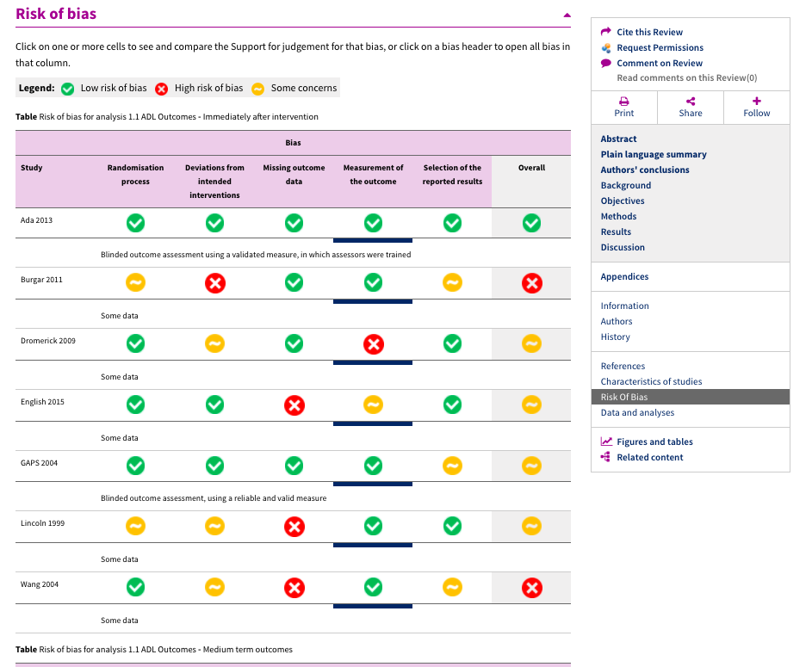

Comment from Agustin Ciaponi on the look of the Outcome-level tables
Hi, I think that the overall RoB should be more clearly separated form each domain both in the table and also in the forset-plots graphs
Comment from Julian Higgins:
I agree with Agustin - perhaps a black circle around the symbols in the Overall column
This feedback will be sent on to the RevMan Web developers.
  - Update on the guidance for reporting RoB 2 in the full Review.
See the recorded version of this web clinic for a demonstration of the reporting guidance tables here. The reporting checklist will be in the Starter pack.
The protocol checklist has been used on 43 protocols. It was developed through our experience and informed by MEs who have used it in practice.
To extend this level of support we have now developed a checklist for reporting of RoB 2 in the full review. It is based on based on the original guidance from the starter pack. We have had feedback from one ME so far and we welcome more.
  - Development of a Welcome Pack for CRGs that have multiple reviews in the pilot and are comfortable and confident taking the lead on new protocols using RoB 2.
We have one CRG where the ME is now comfortable and confident checking RoB 2 in protocols (she has a few in the pilot) and will now be encouraging all newly registered titles to use RoB 2.
For these new reviews, she will be providing all the necessary support to the review teams using RoB 2.
If there are specific questions that the ME cannot answer they can seek support and receive feedback from the Methods Support Unit on the authors behalf.
For MEs that want to look after author teams directly in this way we have created a one page Welcome Pack for these author teams. It covers what material we cover in the kick-off calls.
This option is available to all CRGs once they have looked at a few protocols, used the checklist. We want to ensure MEs/CRGs are comfortable and confident to cover Protocols and reviews with RoB 2. Some CRGs are seeing a lot of protocols come through using RoB 2. For them managing these reviews themselves will be quicker and more streamlined for both the CRG and authors.
If there are any MEs that would like to consider moving to this stage (essentially the beginning of scale-up), please let us know we are keen to support you.

  - Update on the guidance for inputting your Review data into RevMan Web.
We previously advised that you should input all your results analyses data first, then switch on RoB 2 in RMW and input your RoB 2 data.
We’ve been made aware that there is a “duplicating analyses” function, which will be useful for sensitivity or subgroup analysis that includes RoB 2 data.
Therefore the recommended process for adding data to RMW is – input main analysis, switch on RoB in RMW and input the RoB 2, duplicate each analysis for sensitivity or subgroup analysis.
Authors must have checked their review into RevMan Web before switching on RoB 2 otherwise the switch doesn’t work and RoB 1 domains remain in the review.
  - How many Managing Editors and CRGs use Cochrane Forums: https://forums.cochrane.org/.
We received feedback from the Associate Editors that there is a desire for a shared platform that could be used by members of the pilot to engage with the EMD pilot team, possibly the tool developers, with questions or shared learning.
Poll: How many people use Cochrane Forums?
Response: None
Pros:
- Apparently MEs are quite active on it so it could just be designed for MEs (not authors)
- Could save time for us - MEs would be able to see if other MEs have asked a similar question and what the response is (not hidden in personal emails).
- Can create Discussion Boards – either by us as the Pilot Team to get feedback from the community, or maybe the MEs could have their own Discussion Boards?
- Can setup threads and post resources
- Could it be used by members to ask questions/post collaboration opportunities/share updates.
Cons:
- I’ve not used the platform so not what the functionality is like (it looks like it might be quite limited but I’d be keen to give it a go if the MEs would use it).
- Not sure whether MEs will want to use it (but we could ask!).

Questions to be discussed
Question 1 Demián Glujovsky
Signalling question 1.2 If there was no allocation concealment, don't you think that we should still analyze Signalling question 1.3? I know that we are suggesting a change in the algorithm (that was probably analyzed many times by many qualified persons) but it made us feel some uncomfortable to classify as HIGH RoB when allocation concealment was not done (but the rest of the report suggest no imbalances), and just SOME CONCERNS when it was not described and nothing was reported about baseline imbalances either.
2.a Answer:
If we know that allocation was not concealed, then we believe the result should be put at ‘High risk of bias’, irrespective of data about baseline variables. Allocation concealment is the aspect of trial conduct that is most consistently associated with effect estimates in meta-epidemiological studies (see Page et al,* for example). This does not mean that the result is necessarily biased, as you point out, but we consider it unlikely that baseline balance would provide convincing evidence that there was not a problem (since not all variables can be reported in tables). You will be aware that question 1.3 is only ever used to diagnose a problem, and never to provide reassurance. This is a deliberate decision of the tool developers. These days there is rarely justification for not using allocation concealment, since it is straightforward for most trials and its importance has been known for a long time. Of course, an implication of this is that a lack of information about allocation concealment is most commonly due to space restrictions or oversight rather than failure to do it, and this lack of information (in combination with randomization) leads to a judgement of ‘Some concerns’.
* https://journals.plos.org/plosone/article?id=10.1371/journal.pone.0159267

Additional Comment: Demián Glujovsky

Additional Comment:
Michellle Hilton-Boon.
No allocation concealment would lead to the possibility that any balance on baseline covariates was contrived through interference in allocation. So in addition to the points that have been made, 1.3 should not be used to provide evidence of no problem due to allocation concealment.

Question 2 (Katie Webster)
For domain 3.1 - Were data for this outcome available for all, or nearly all participants randomised?
How should this be rated if the exact number of individuals included for the specific outcome was not clear, but overall the drop out was acceptable for the trial? We have some outcomes where it is not clear how many participants contributed (e.g. questionnaires, and we don't know if everyone filled them out), although the flow chart for the trial shows that overall there were few drop outs. Should we rate this as "probably yes" - as we know there were few drop-outs overall, or "no information" as the authors do not state the number of people who were actually included in this outcome?
Answer:
This may be the situation when a reviewer is using an effect estimate for which no overall n is reported. If you have reason to believe that the amount of missing data is trivial then yes you can answer “Probably yes” without knowing exact numbers.

Question 3 (Katherine Jones)
This question is regarding differences between studies that have a protocol available and those that don’t, and whether this should be taken into account. I just wonder whether the publishing of the protocol is viewed as supplementary or essential. If there are substantial differences e.g. in in the randomisation methods reported in a published protocol versus the published full text paper, is this still comparable with another study's risk of bias judgement when there is only a published full text paper?
Answer:
Kerry replied: Unfortunately I think its classed as supplementary as it is not available for all trials – especially older ones. Obviously all trials should be registered now so that should obviously be taken into account – but again the level of detail varies wildly. This is one reason the tools asks you to specify the documents you have to hand and that should be made available in an online repository. If you think this is an issue within a particular review you could always highlight it in the text for risk of bias and in the discussion and do a post-hoc sensitivity analysis by extra documents/contact available versus trial report only.
Julian replied: The protocol is just a source of information about a trial, and often there are several source of information. Sources of information do not always agree. They might not even agree between ‘Methods’ and ‘Results’ sections of a published report of the final trial results. Users of the tool should make a judgement about each signalling question based on the totality of information available to them. There will obviously be less certainty in this judgement if a protocol is available and disagrees with the final report. There is no reason to add further consideration of protocols to Domain 1 of the tool.
Question 4 Demián Glujovsky
Signalling question Q5.1 If no protocol registration is published, should we respond NI (No information)? In that case, the absence of a protocol registration will make the Overall RoB at least with Some concerns.
Answer:
If there is no protocol or trial registry information then yes NI is correct.
Question 5 (Katie Webster)
For domain 5.2 - Were the data analysed in accordance with a pre-specified analysis plan?
If no analysis plan is available, should you ever rate this as "probably yes", or is the response always "no information" or "no/probably no"? The signalling questions in the guidance suggest that you could infer reporting bias even without an analysis plan (discrepancies in different reports, unusual groupings etc), but it is not clear whether you can infer no bias in the absence of a plan. For example, if we have a study that reports the outcome in a standard way, as described in the methods of an article, but there is no statistical analysis plan, do we rate as "probably yes" or "no information"?
(if this is rated as "no information" then it will automatically change the overall risk of bias for the outcome to "some concerns", so it might mean that any study without an identifiable published analysis plan will have some concerns for ROB2)
Answer:
Kerry: You could answer PY if this is a standard way that you would expect in this clinical area and you have no concerns regarding selective reporting.
Julian: I agree – if it is obvious what the protocol/SAP was very likely to have said, you can make that call (As Probably yes) even if you don’t have access to it.
Empirical evidence on this is quite frightening between 7% and 88% (Dwan et al 2014) of trials change their analysis from their plan to their protocol. Evidence shows that they change the type of analyses, the timepoints and other aspects of selective outcome reporting.
See the evidence here. https://journals.plos.org/plosmedicine/article?id=10.1371/journal.pmed.1001666

Question 6 Kerry Dwan
What stage is the crossover tool at? And will there be an excel tool specifically for the crossover extension?

Answer:
There may or may not be an Excel version, depending on several factors. There is planned to be an interactive implementation of some sort, however.
There is an online tool in development that has been ready for 8 months. Unfortunately the University has not made a server available for the tool be situated. The online tool includes both cross-over and cluster RCTs.
- Any other questions or feedback from pilot teams on using RoB 2 - anything to share from reviews in the pilot, such as tricks, tips or challenges.
- Recent updates to the RoB 2 Pilot Starter Pack.

New July 2020 version of the Starter Pack includes:
- Tweaks to the protocol reporting guidance (checklist table added) and inclusion of some additional guidance for certain points
- New full review reporting guidance
- In the tips from other review team section:
  - Authors must have checked their review into RevMan Web before switching on RoB 2 otherwise the switch doesn’t work and RoB 1 domains remain in the review.
  - Once RoB 2 functionality has been switched on in your Review, you’ll need to log out and log in again to see the changes.
  - The new order that we advise data should be input into RMW so authors can duplicate the analyses for sensitivity and subgroup analyses.

- Next web clinic – Thursday 27 August, 09:00-10:00 (BST).
- Request from Ella Flemyng to all pilot review groups to drop us a brief email with the status of your review for our records.

